Banquets (משתה) in Megillat Esther

The following chart is from Michael Fox’s book, Character and Ideology in the Book of Esther:

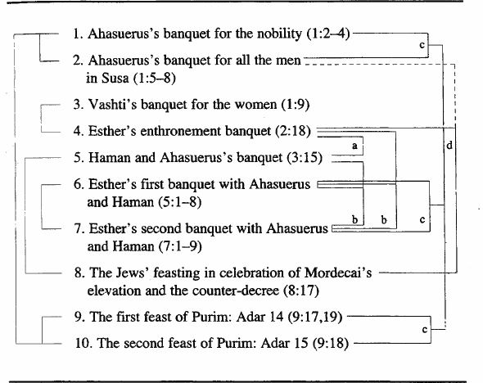

As can be seen, the banquets tend to come in pairs – such as Esther’s two banquets for the king and Haman (5:4-8 with 7:1-9) and the two celebratory banquets of Purim (9:17-19; 9:18) – or even triplets – the three banquets at the beginning of the book (1:2-4, 1:5-8, and 1:9). Esther’s enthronement (2:18) may be a contrastive pair with Haman’s banquet with the king (3:15), or else may be a pair with the “women’s banquet” thrown by Vashti in 1:9. On this reading, the banquet enjoyed by Haman and the king in 3:15 may contrast with the Jews’ celebration at a banquet in 8:17.

