Worksheet: The status of Jehoiachin in Babylon

2 Kings 25:27-30 relates that when Evil-merodach (= Amel Marduk) came to the throne (i.e., in 561), he released Jehoiachin from prison and gave him a position of honor.
כז וַיְהִי בִשְׁלֹשִׁים וָשֶׁבַע שָׁנָה לְגָלוּת יְהוֹיָכִין מֶלֶךְ-יְהוּדָה בִּשְׁנֵים עָשָׂר חֹדֶשׁ בְּעֶשְׂרִים וְשִׁבְעָה לַחֹדֶשׁ נָשָׂא אֱוִיל מְרֹדַךְ מֶלֶךְ בָּבֶל בִּשְׁנַת מָלְכוֹ אֶת-רֹאשׁ יְהוֹיָכִין מֶלֶךְ-יְהוּדָה מִבֵּית כֶּלֶא. כח וַיְדַבֵּר אִתּוֹ טֹבוֹת וַיִּתֵּן אֶת-כִּסְאוֹ מֵעַל כִּסֵּא הַמְּלָכִים אֲשֶׁר אִתּוֹ בְּבָבֶל. כט וְשִׁנָּא אֵת בִּגְדֵי כִלְאוֹ וְאָכַל לֶחֶם תָּמִיד לְפָנָיו כָּל-יְמֵי חַיָּיו. ל וַאֲרֻחָתוֹ אֲרֻחַת תָּמִיד נִתְּנָה-לּוֹ מֵאֵת הַמֶּלֶךְ דְּבַר-יוֹם בְּיוֹמוֹ כֹּל יְמֵי חַיָּו.
Look up אויל-מרֹדך (known as Amel-Marduk in English and in Babylonian).
- What year did he come to the throne, and release Yehoiachin from בית הכלא? _____________
- From what year until what year was Yehoiachin imprisoned? ________ to __________.
In some tablets discovered in Babylon in the early 1900s were found “ration lists” – administrative texts that stipulated how much oil was to be given to various people.
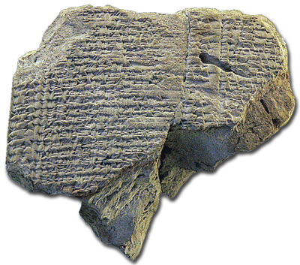
One of these texts reads:
10 (qû of oil) to Yaukin, the king of Judah;
2 1/2 qû (oil) to the offspring of Judah’s king;
4 qû to eight men from Judea.
Another reads:
1 1/2 qû (oil) for three carpenters from Arvad, 1/2 apiece
11 1/2 qû for eight wood workers from Byblos. . .
3 1/2 qû for seven Greek craftsman, 1/2 sila apiece
1/2 qû to the carpenter, Nabuetir
10 qû to Yaukin, the son of Judah’s king
2 1/2 qû for the five sons of the Judean king.
- How much oil did the typical person get? _______________
- How much oil did Yehoiachin get? ______________________
- What does this suggest about Yehoiachin’s status while in “prison”? _________________________ __________________________________________________________________________________________
- What other evidence is there from this text regarding Yehoiachin’s status while in prison? __________________________________________________________________________________________

