Worksheet: Cyrus’ declaration and the beginning of the return to Judah

After consolidating his power to the east of Babylonia, stretching into central Asia, Cyrus captured Babylon in 539, and took over the territory of the Neo-Babylonian Empire.
The “Cyrus Cylinder,” which records Cyrus’ view of his own rise to power and what he did when he arrived in Babylon, is today in the British Museum.
Please watch the TED talk by Dr Neil Macgregor, then the director of the British Museum, on the Cyrus Cylinder:
https://www.youtube.com/watch?v=QpmsftF2We4
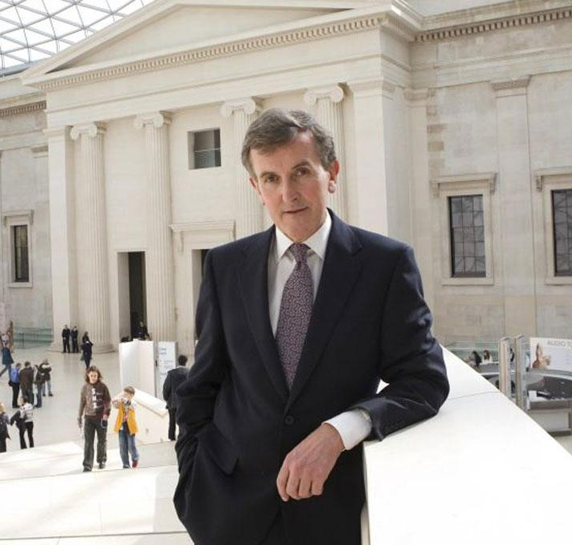 | 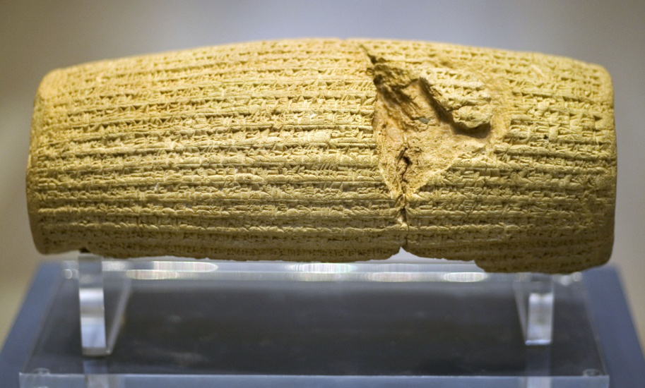

Cyrus’ Proclamation
Ex[alted Marduk…. took under his hand Cyrus, king of the city of Anshan, and called him by his name, proclaiming him aloud for the kingship over all of everything. He made the land of the Qutu and all the Medean troops prostrate themselves at his feet, while he looked out in justice and righteousness for the black-headed people whom he had put under his care. Marduk, the great lord, who nurtures his people, saw with pleasure his fine deeds and true heart and ordered that he should go to Babylon He had him take the road to Tintir, and, like a friend and companion, he walked at his side. His vast troops whose number, like the water in a river, could not be counted, marched fully-armed at his side. He had him enter without fighting or battle right into [Babylon]; he saved his city Babylon from hardship. He handed over to him Nabonidus, the king who did not fear him. All the people of Tintir, of all Sumer and Akkad, nobles and governors, bowed down before him and kissed his feet, rejoicing over his kingship and their faces shone. The lord through whose trust all were rescued from death and who saved them all from distress and hardship, they blessed him sweetly and praised his name.
I am Cyrus, king of the universe, the great king, the powerful king, king of Babylon, king of Sumer and Akkad, king of the four quarters of the world, son of Cambyses, the great king,, king of the city of Anshan, grandson of Cyrus, the great king, ki[ng of the ci]ty of Anshan, descendant of Teispes, the great king, king of Anshan, the perpetual seed of kingship, whose reign Bel and Nabu love, and with whose kingship, to their joy, they concern themselves.
When I went as harbinger of peace i[nt]o Babylon I founded my sovereign residence within the palace amid celebration and rejoicing. Marduk, the great lord, bestowed on me as my destiny the great magnanimity of one who loves Babylon, and I every day sought him out in awe. … From [[Babylon]] I sent back to their places to the city of Ashur and Susa, Akkad, the land of Eshnunna, the city of Zamban, the city of Meturnu, Der, as far as the border of the land of Qutu - the sanctuaries across the river Tigris - whose shrines had earlier become dilapidated, the gods who lived therein, and made permanent sanctuaries for them. I collected together all of their people and returned them to their settlements, and the gods of the land of Sumer and Akkad which Nabonidus – to the fury of the lord of the gods – had brought into [Babylon], at the command of Marduk, the great lord, I returned them unharmed to their cells, in the sanctuaries that make them happy.

According to Cyrus’ text, what did he do with the people who had been exiled by the Babylonians? __________________________________________________________________________________________________
What does he mean that he “returned … the gods … unharmed to their cells”? _______________________ __________________________________________________________________________________________________

Cyrus’ Proclamation as heard by the Jews
At the beginning of Ezra (1:1-4), we read:
א וּבִשְׁנַת אַחַת לְכוֹרֶשׁ מֶלֶךְ פָּרַס לִכְלוֹת דְּבַר-ה’ מִפִּי יִרְמְיָה הֵעִיר ה’ אֶת-רוּחַ כֹּרֶשׁ מֶלֶךְ-פָּרַס וַיַּעֲבֶר-קוֹל בְּכָל-מַלְכוּתוֹ וְגַם-בְּמִכְתָּב לֵאמֹר. ב כֹּה אָמַר כֹּרֶשׁ מֶלֶךְ פָּרַס כֹּל מַמְלְכוֹת הָאָרֶץ נָתַן לִי ה’ אֱלֹהֵי הַשָּׁמָיִם וְהוּא-פָקַד עָלַי לִבְנוֹת-לוֹ בַיִת בִּירוּשָׁלִַם אֲשֶׁר בִּיהוּדָה. ג מִי-בָכֶם מִכָּל-עַמּוֹ יְהִי אֱלֹהָיו עִמּוֹ וְיַעַל לִירוּשָׁלִַם אֲשֶׁר בִּיהוּדָה וְיִבֶן אֶת-בֵּית ה’ אֱלֹהֵי יִשְׂרָאֵל הוּא הָאֱלֹהִים אֲשֶׁר בִּירוּשָׁלִָם. ד וְכָל-הַנִּשְׁאָר מִכָּל-הַמְּקֹמוֹת אֲשֶׁר הוּא גָר-שָׁם יְנַשְּׂאוּהוּ אַנְשֵׁי מְקֹמוֹ בְּכֶסֶף וּבְזָהָב וּבִרְכוּשׁ וּבִבְהֵמָה עִם-הַנְּדָבָה לְבֵית הָאֱלֹהִים אֲשֶׁר בִּירוּשָׁלִָם.
In the first year of Cyrus, king of Persia, when the word of the Lord had ceased from the mouth of Jeremiah, the Lord roused the spirit of Cyrus, king of Persia, and he proclaimed throughout his kingdom, and also in writing, as follows:
“Thus said King Cyrus of Persia: The Lord God of Heaven has given me all the kingdoms of the earth and has charged me with building Him a house in Jerusalem, which is in Judah. Anyone of you of all His people—may his God be with him, and let him go up to Jerusalem that is in Judah and build the House of the Lord God of Israel, the God that it is Jerusalem; and all who stay behind, wherever he may be living, let the people of his place assist him with silver, gold, goods, and livestock, besides the freewill offering to the House of God that is in Jerusalem.”

What aspects of the way Cyrus presents himself are also found in this text? __________________________ ____________________________________________________________________________________________________________________________________________________________________________________________________
What is different about the way that Cyrus’ actions and policies are portrayed here, as opposed to in the Cyrus cylinder?
- Who inspired Cyrus: ______________________________________________________________________
__________________________________________________________________________________________
- Which temples are mentioned: ____________________________________________________________
__________________________________________________________________________________________
- The participation of people who do not return: ____________________________________________
__________________________________________________________________________________________

Extra texts from תנ"ך: Isaiah 44-45
The navi in Isaiah 44-45 describes Cyrus by name, foretelling that he would save the Jews from the Babylonian exile:
Isaiah 44:24-28:
It is I, the Lord, who made everything, Who alone stretched out the heavens and unaided spread out the earth…It is I who say of Jerusalem, ‘It shall be inhabited,’ and of the towns of Judah, ‘they shall be rebuilt, and I shall restore their ruined places.’ The one who said to the deep, ‘Be dry; I will dry up your floods,’ am the same who says of Cyrus, ‘He is my shepherd; he shall fulfill all my purposes!’ He shall say of Jerusalem, ‘She shall be rebuilt,’ and to the Temple, ‘You shall be founded again.’
Isaiah 45:1-8:
Thus said the Lord to Cyrus, His anointed one, whose right hand I have grasped…‘I will march before you and level the hills that loom up; I will shatter doors of bronze and cut down iron bars…I engird you, though you have not known Me.’
In what way does the navi agree with Cyrus’ depictions of his actions, and in what theological way does he disagree? _________________________________________________________________________________ ____________________________________________________________________________________________________________________________________________________________________________________________________

